**Practical 1**

Source code Management using Git & GitHub, GitLab in Collaborative teaming, Store, marge, version control of the code

**Create new repo**

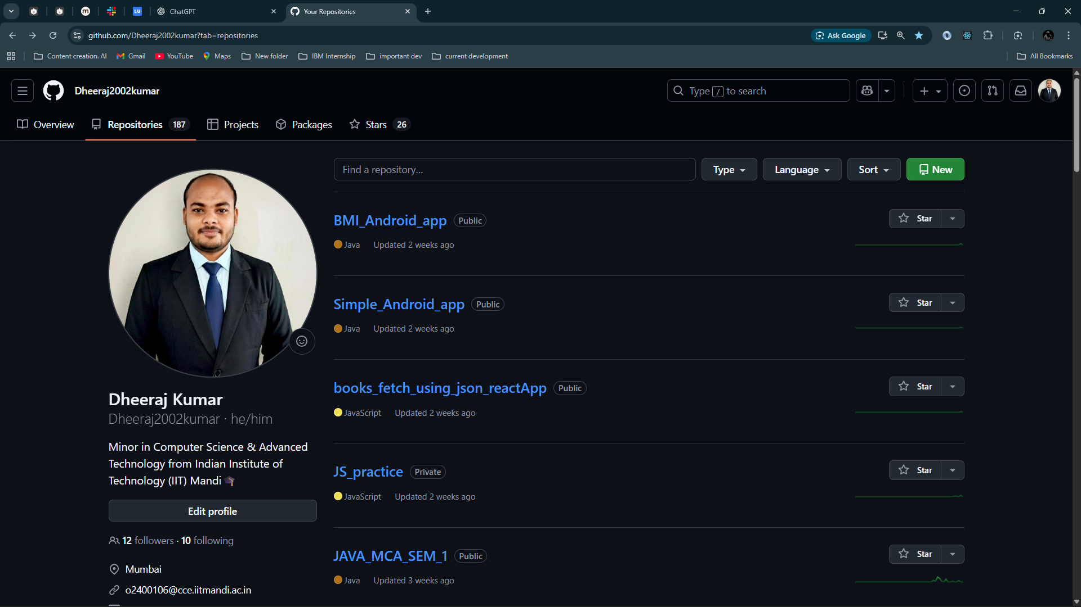

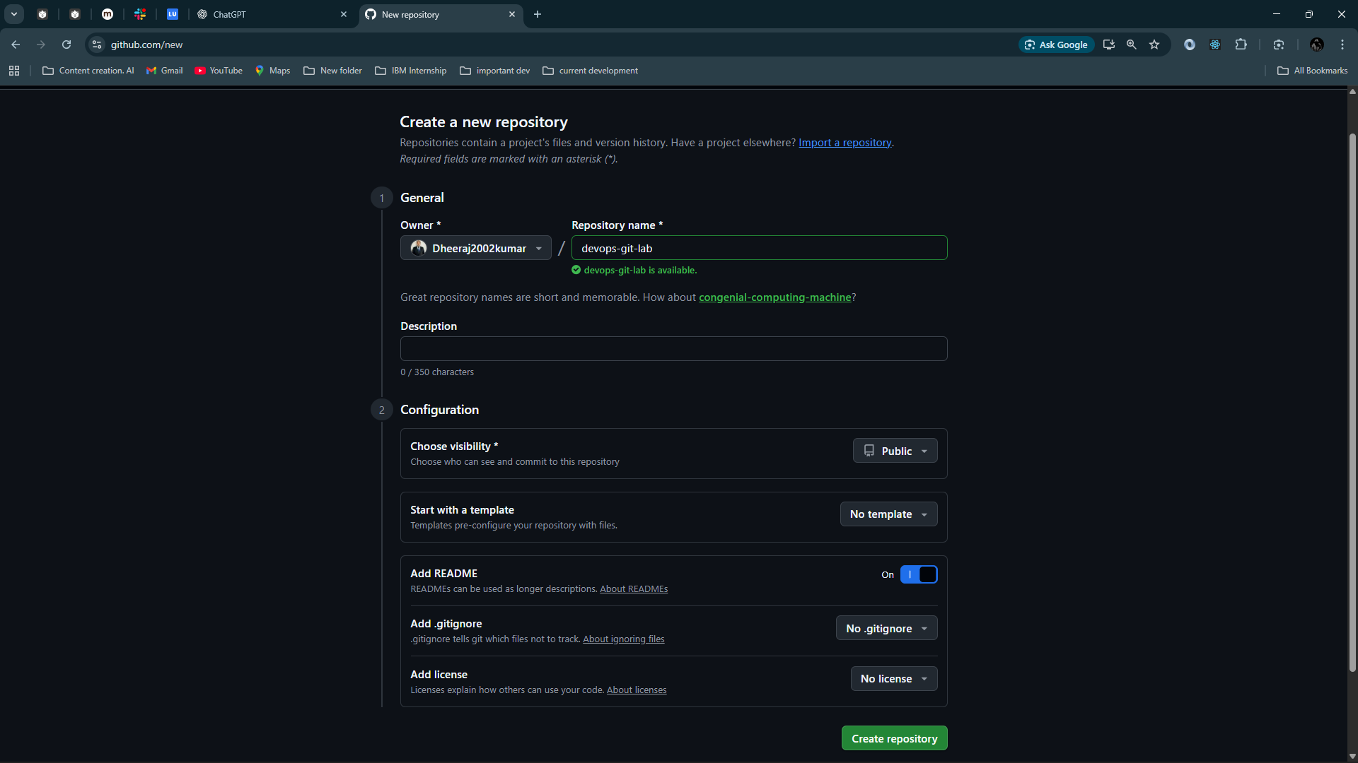 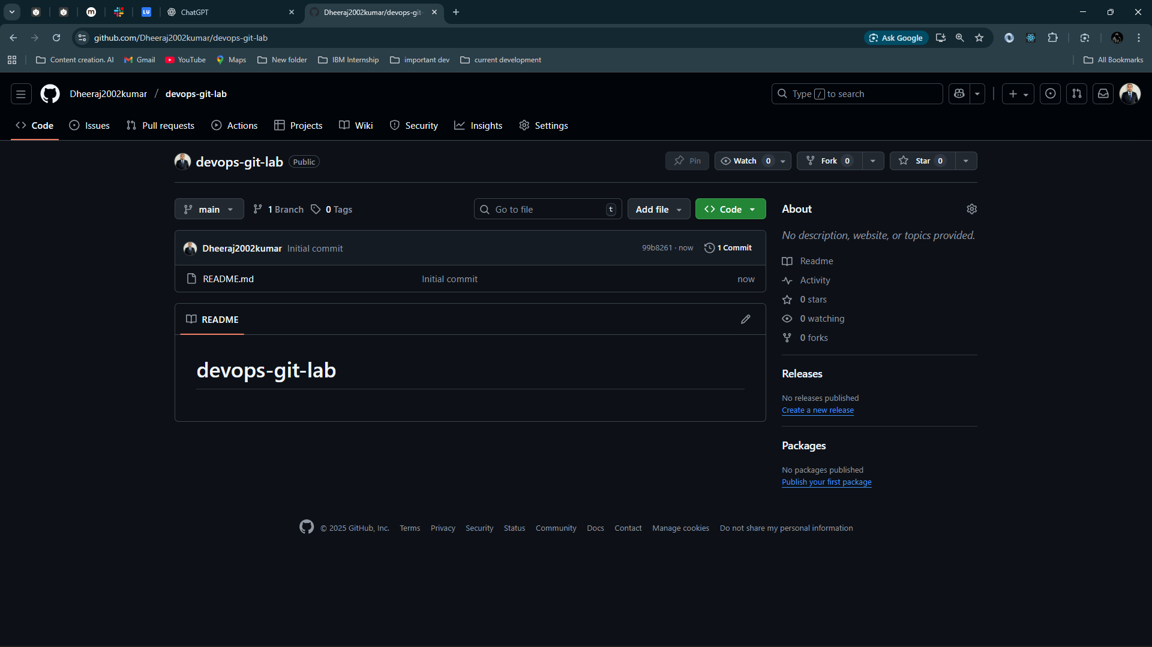

Copy the url and clone it

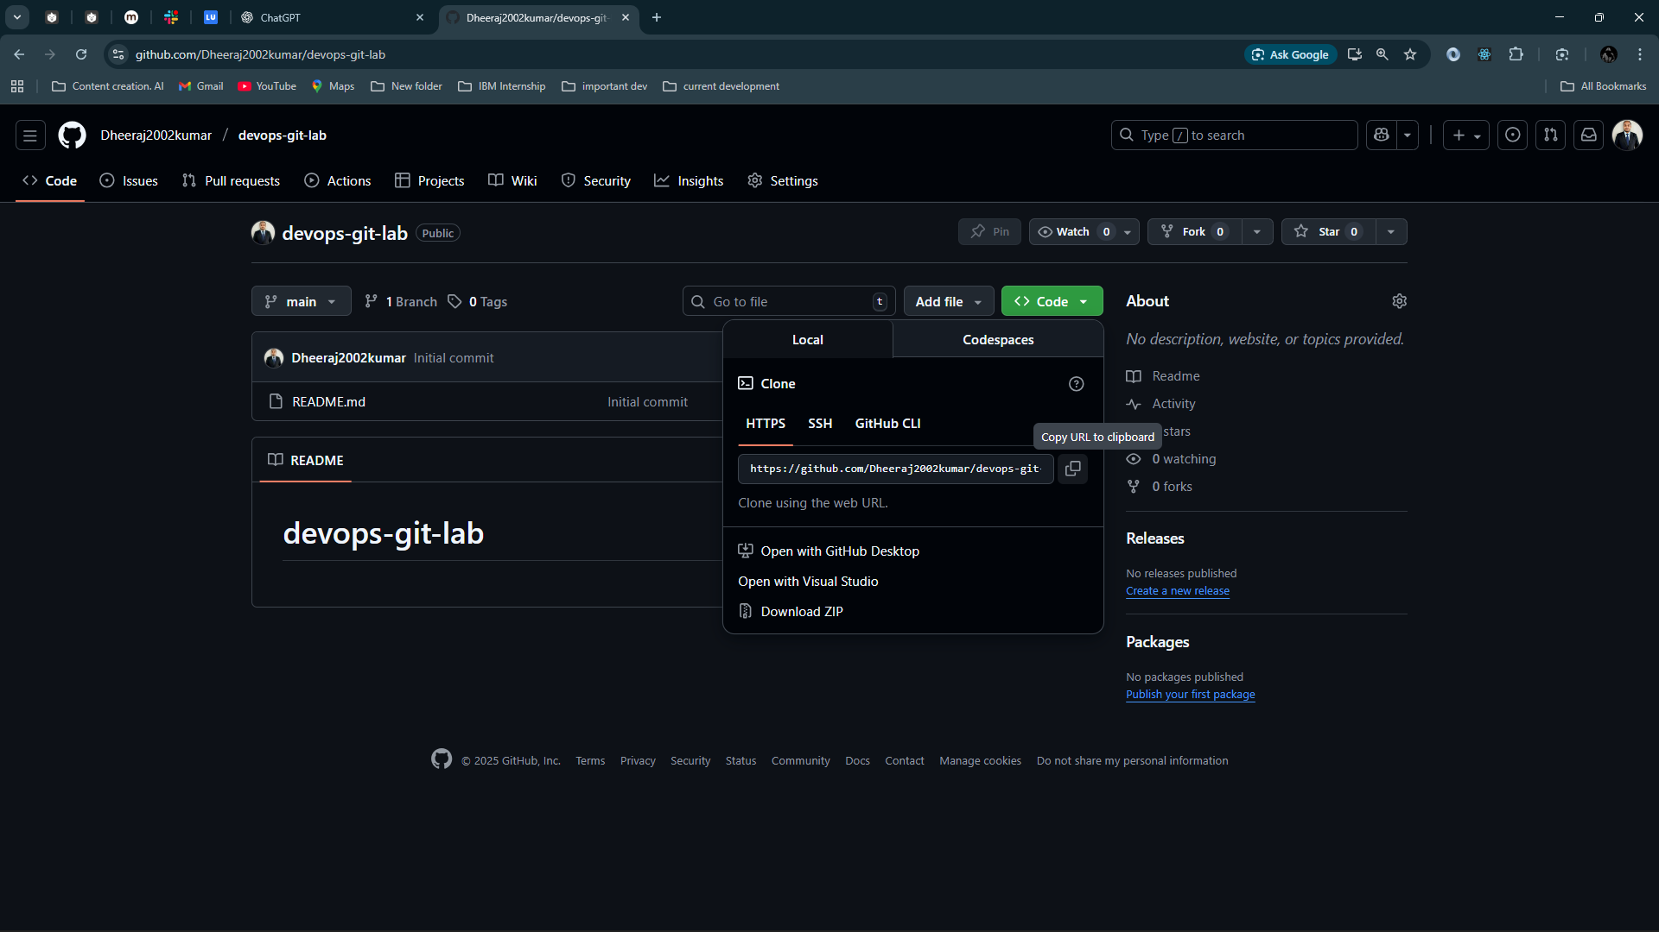

# **Clone the Repository for Collaboration**

A collaborator would run:

git clone https://github.com/Dheeraj2002kumar/devops-git-lab.git

cd devops-git-lab

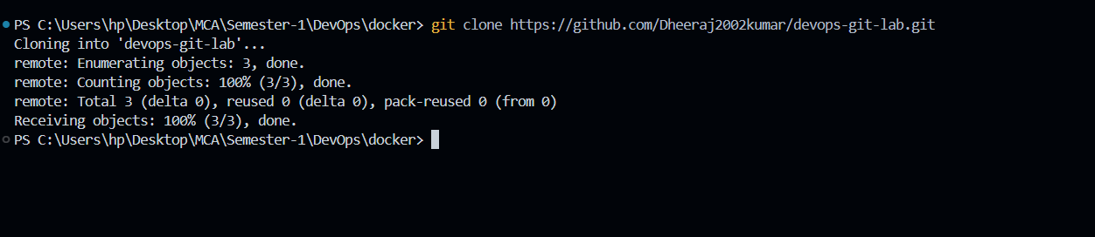

Create your sample file:

echo "This is test.txt for Git lab." > test.txt

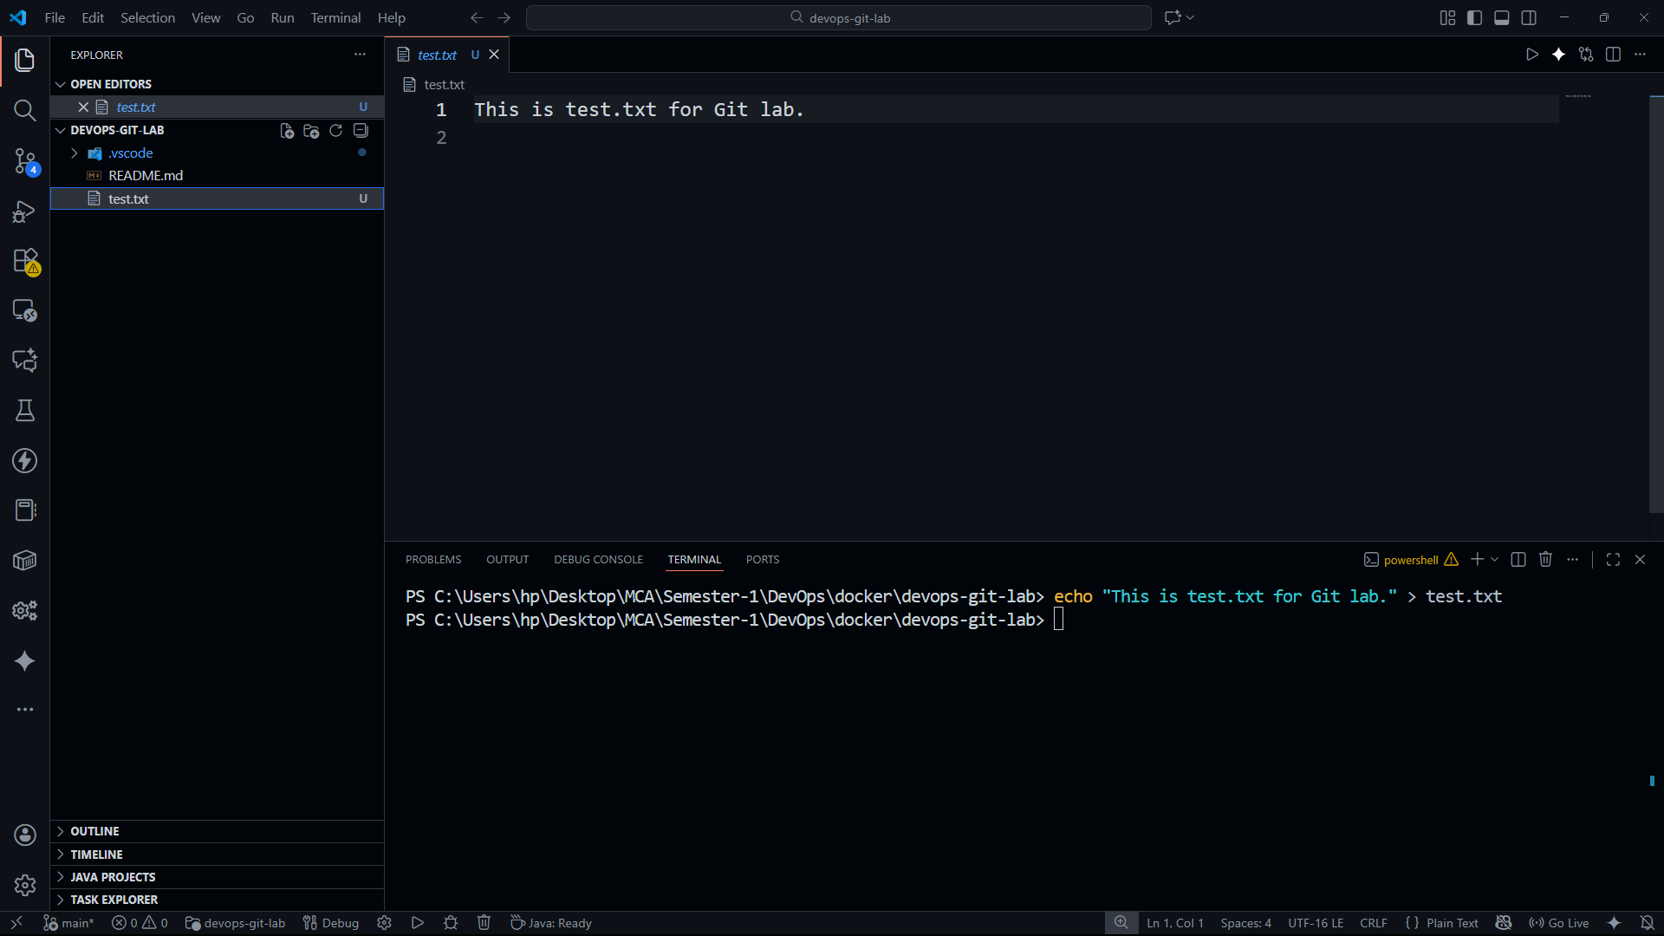

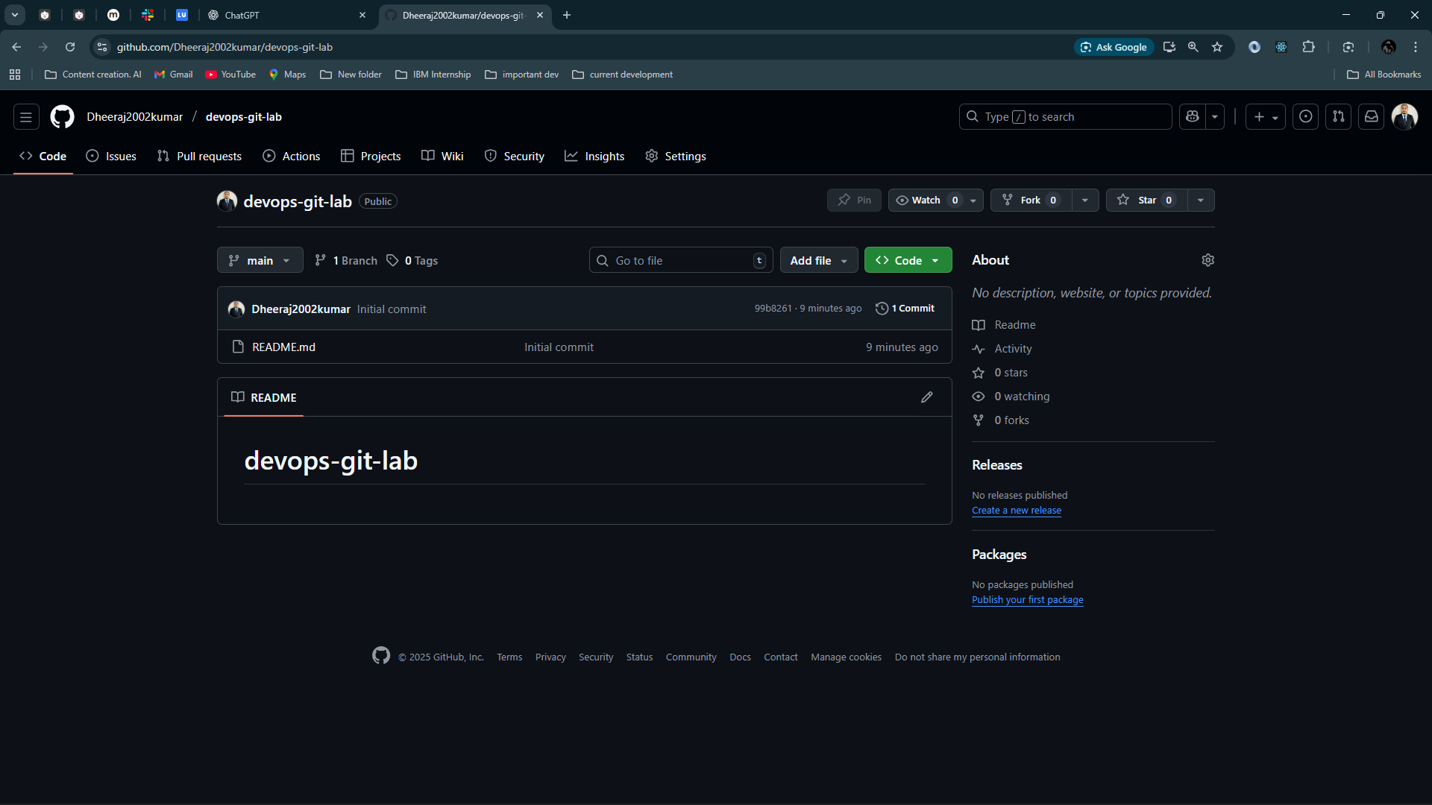

Push the code txt file in github

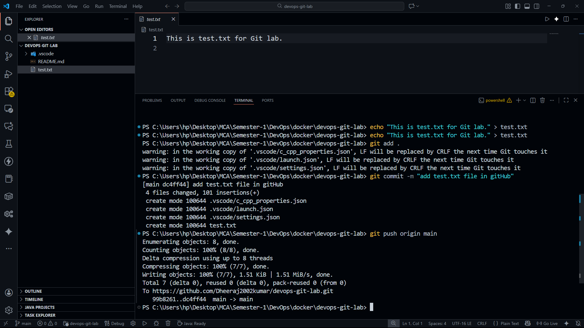

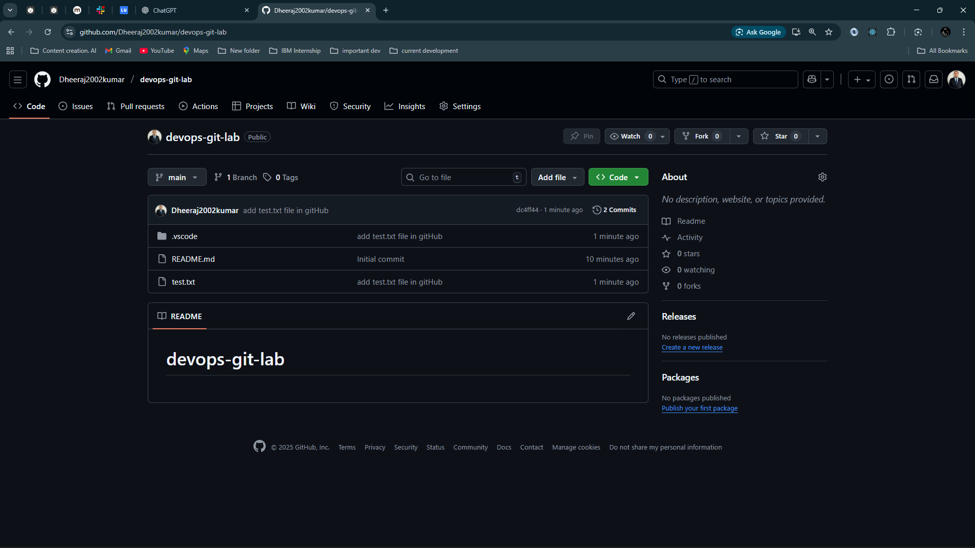

You can see the test.txt file

# **Create a New Branch for Editing test.txt**

git checkout -b feature-update-testfile

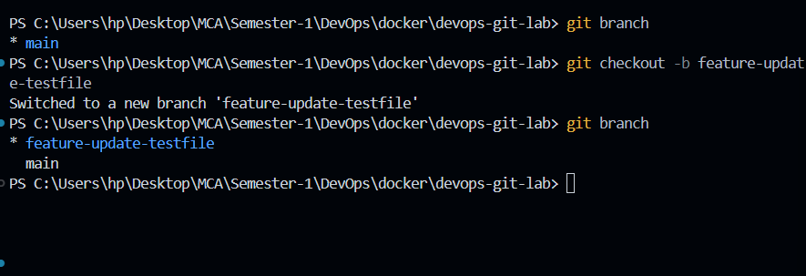

Modify the file:

echo "New update: Version 2" >> test.txt

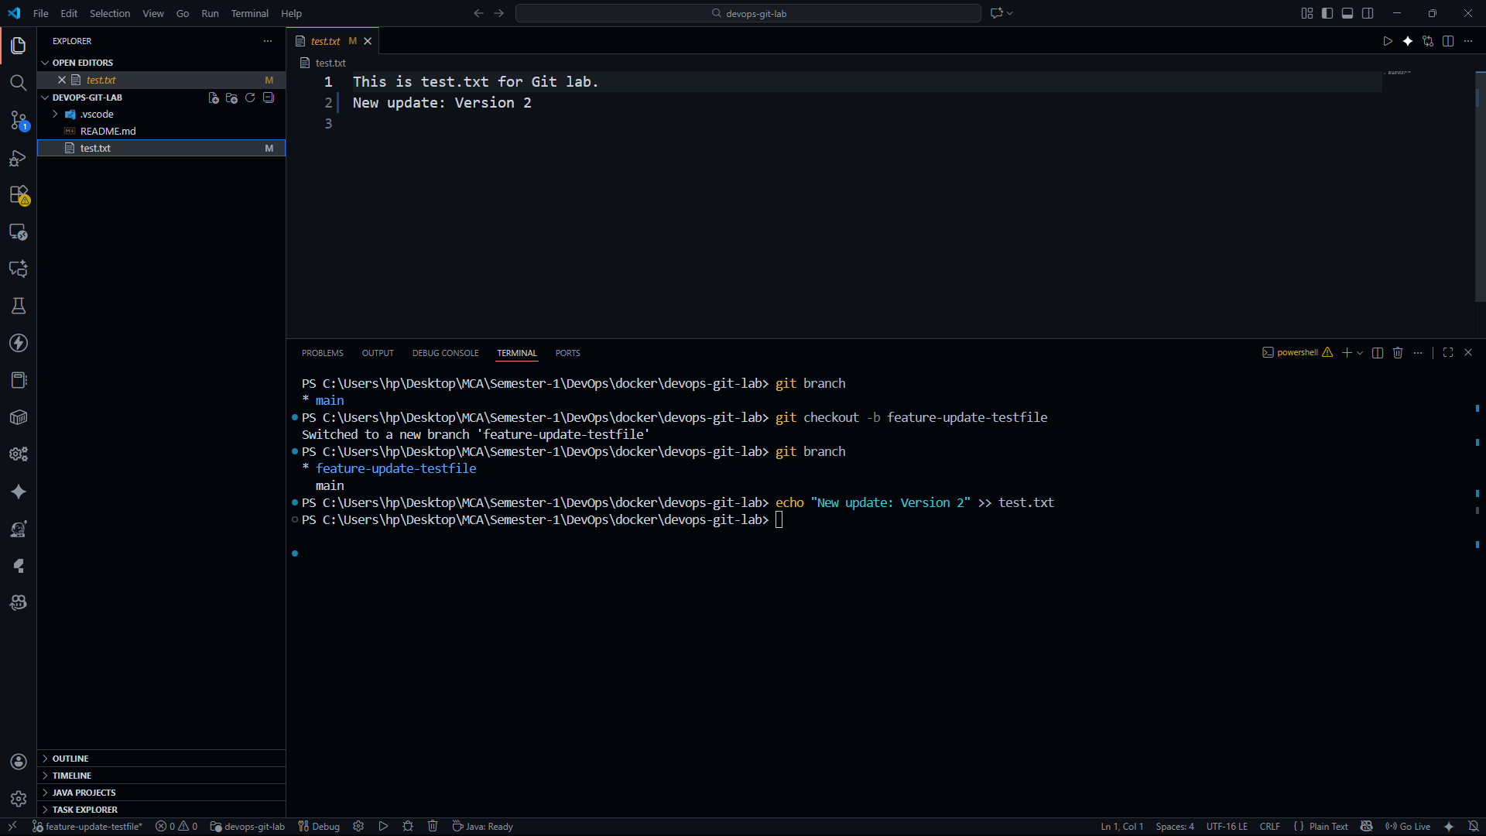

Stage and commit:

git add test.txt

git commit -m "Added version 2 update in test.txt"

Push the branch:

git push origin feature-update-testfile

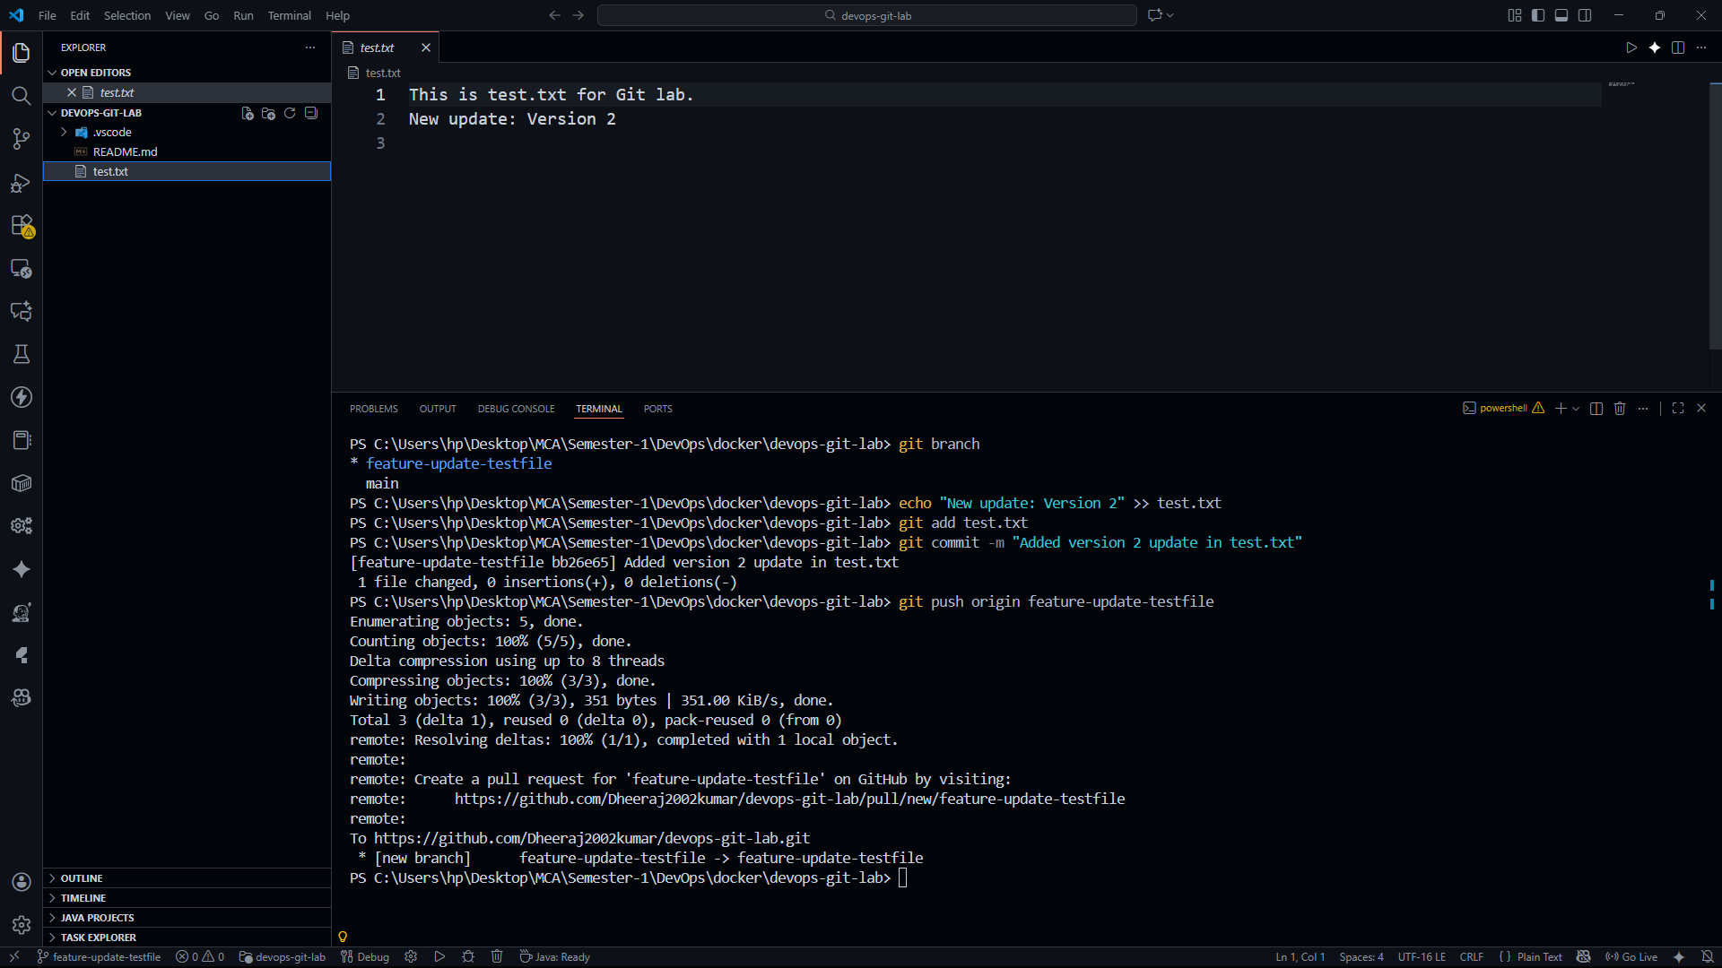

# **Create a Pull Request (PR)**

In GitHub:

1. Open the repo
2. Click **Compare & Pull Request**
3. Add title: “Update test.txt to version 2”
4. Add description
5. Submit PR
6. Another team member reviews
7. Click **Merge Pull Request**

### Update your local repo after merge:

git checkout main

git pull origin main

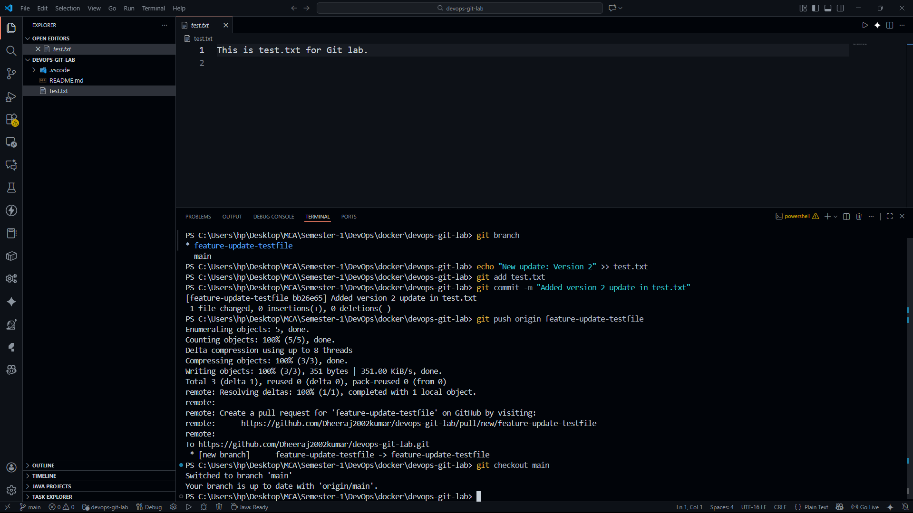

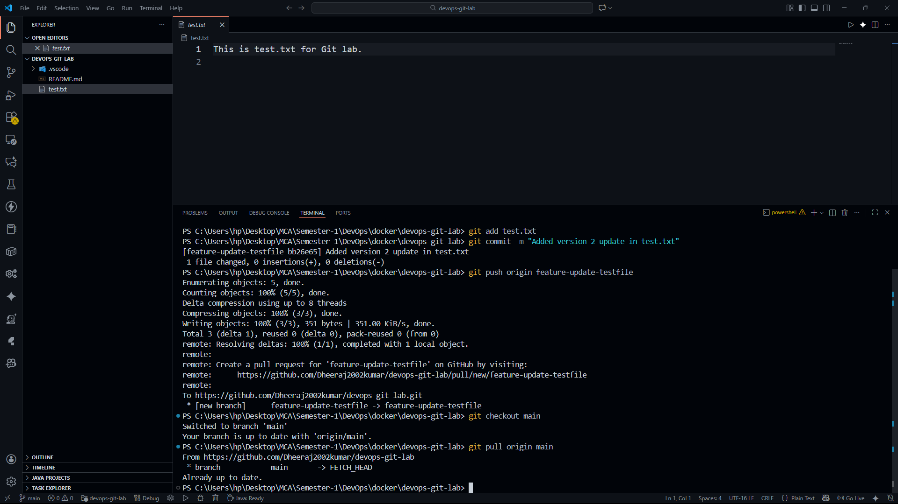

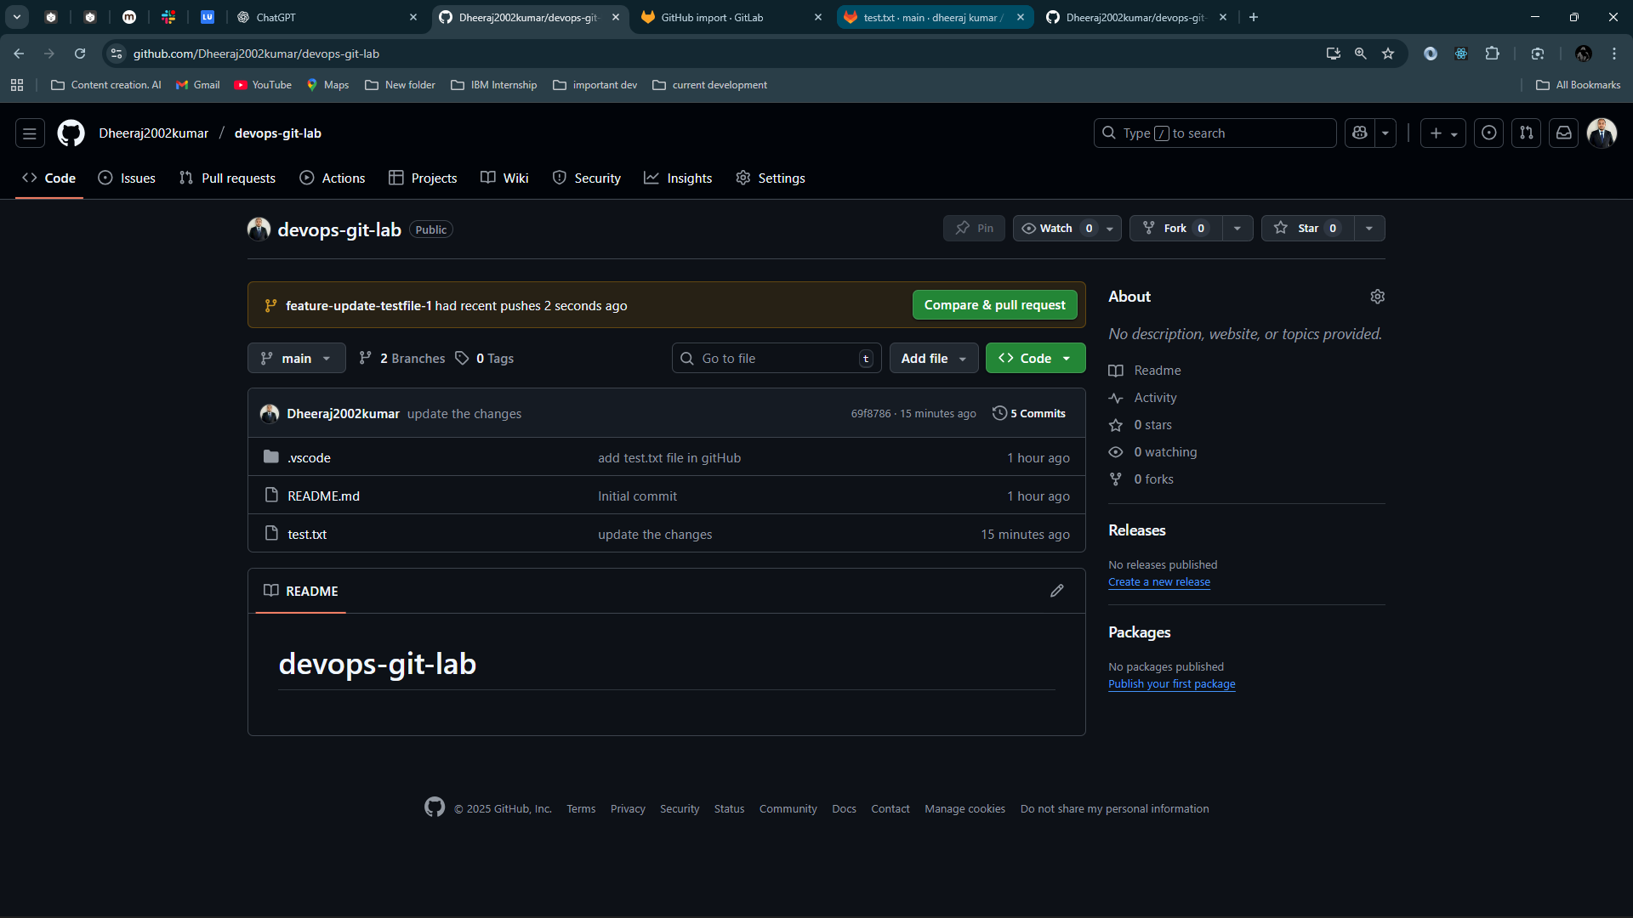

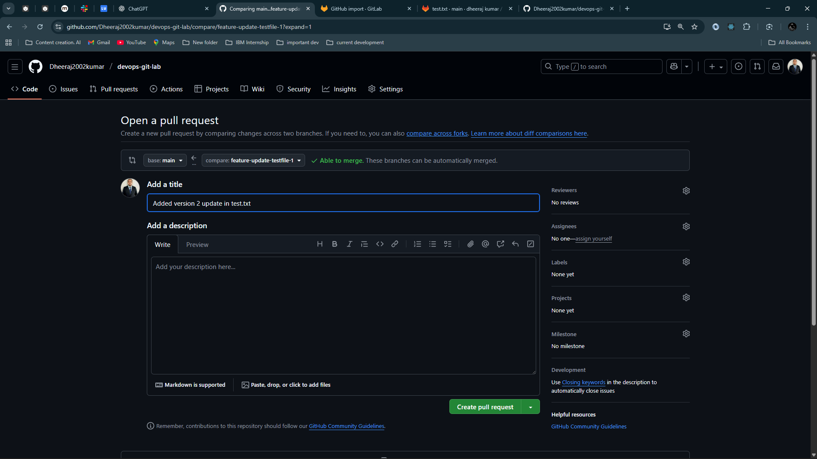

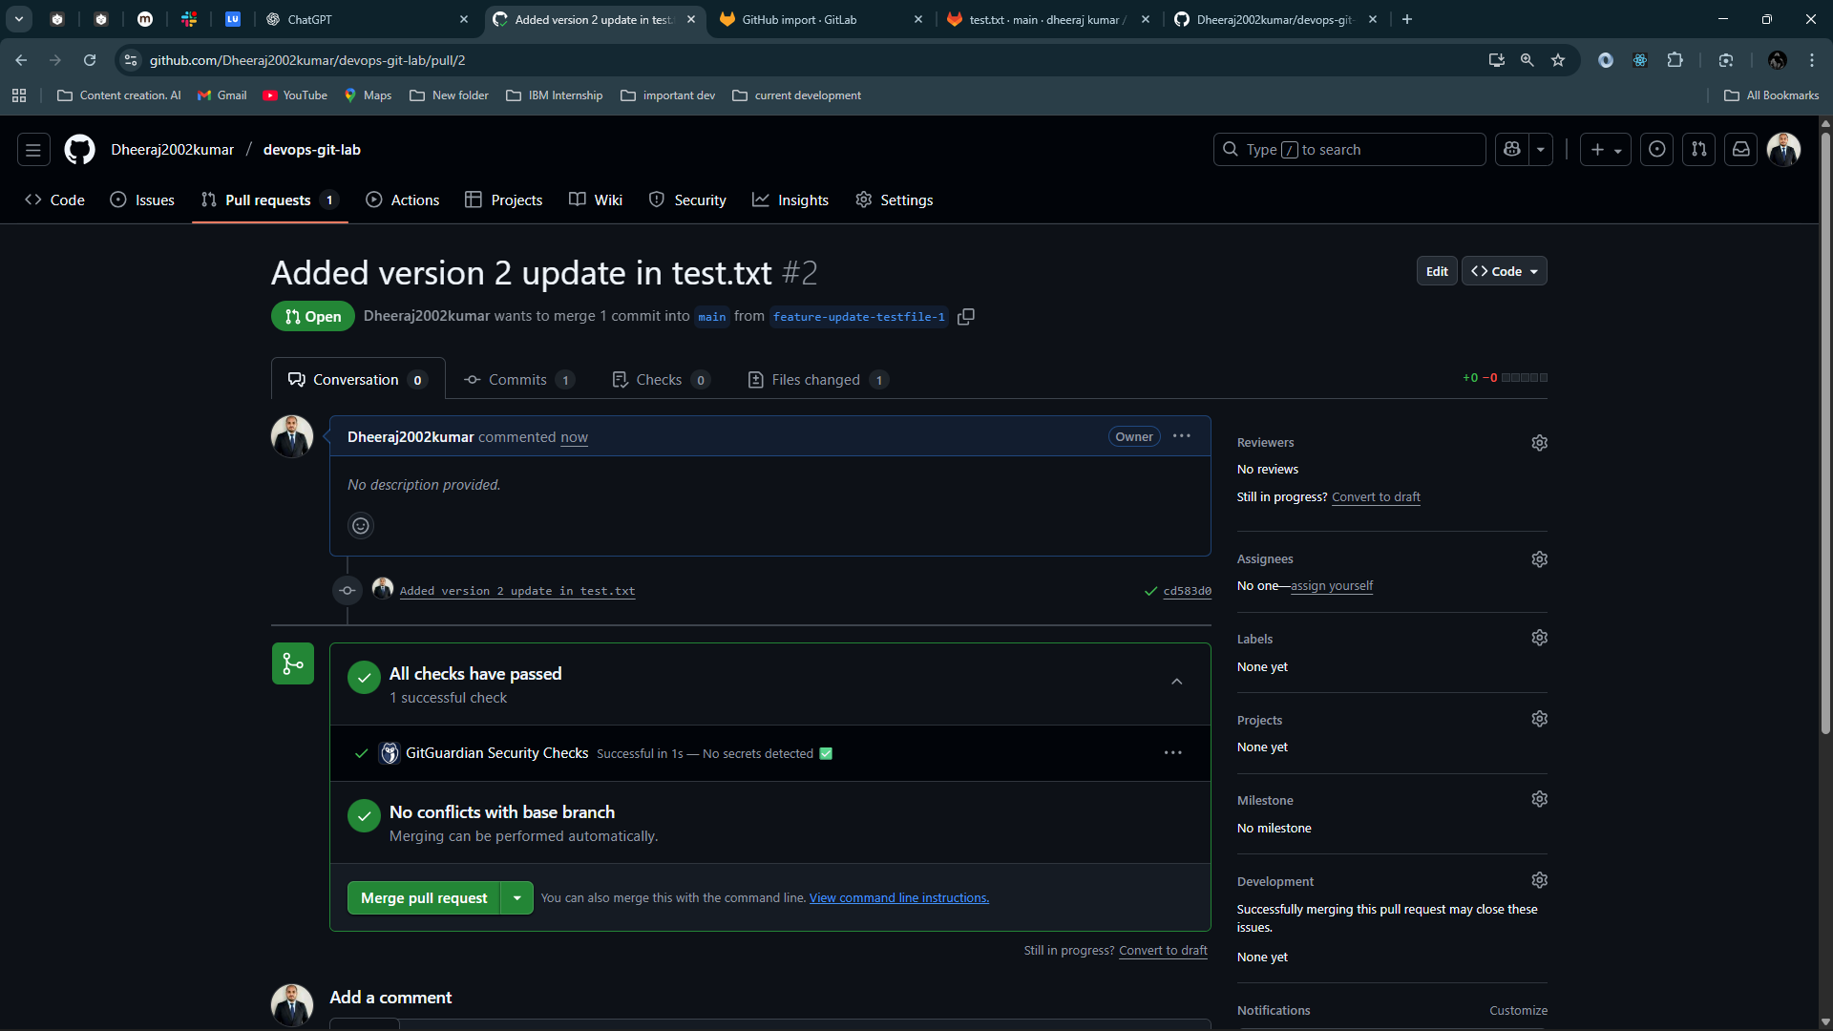

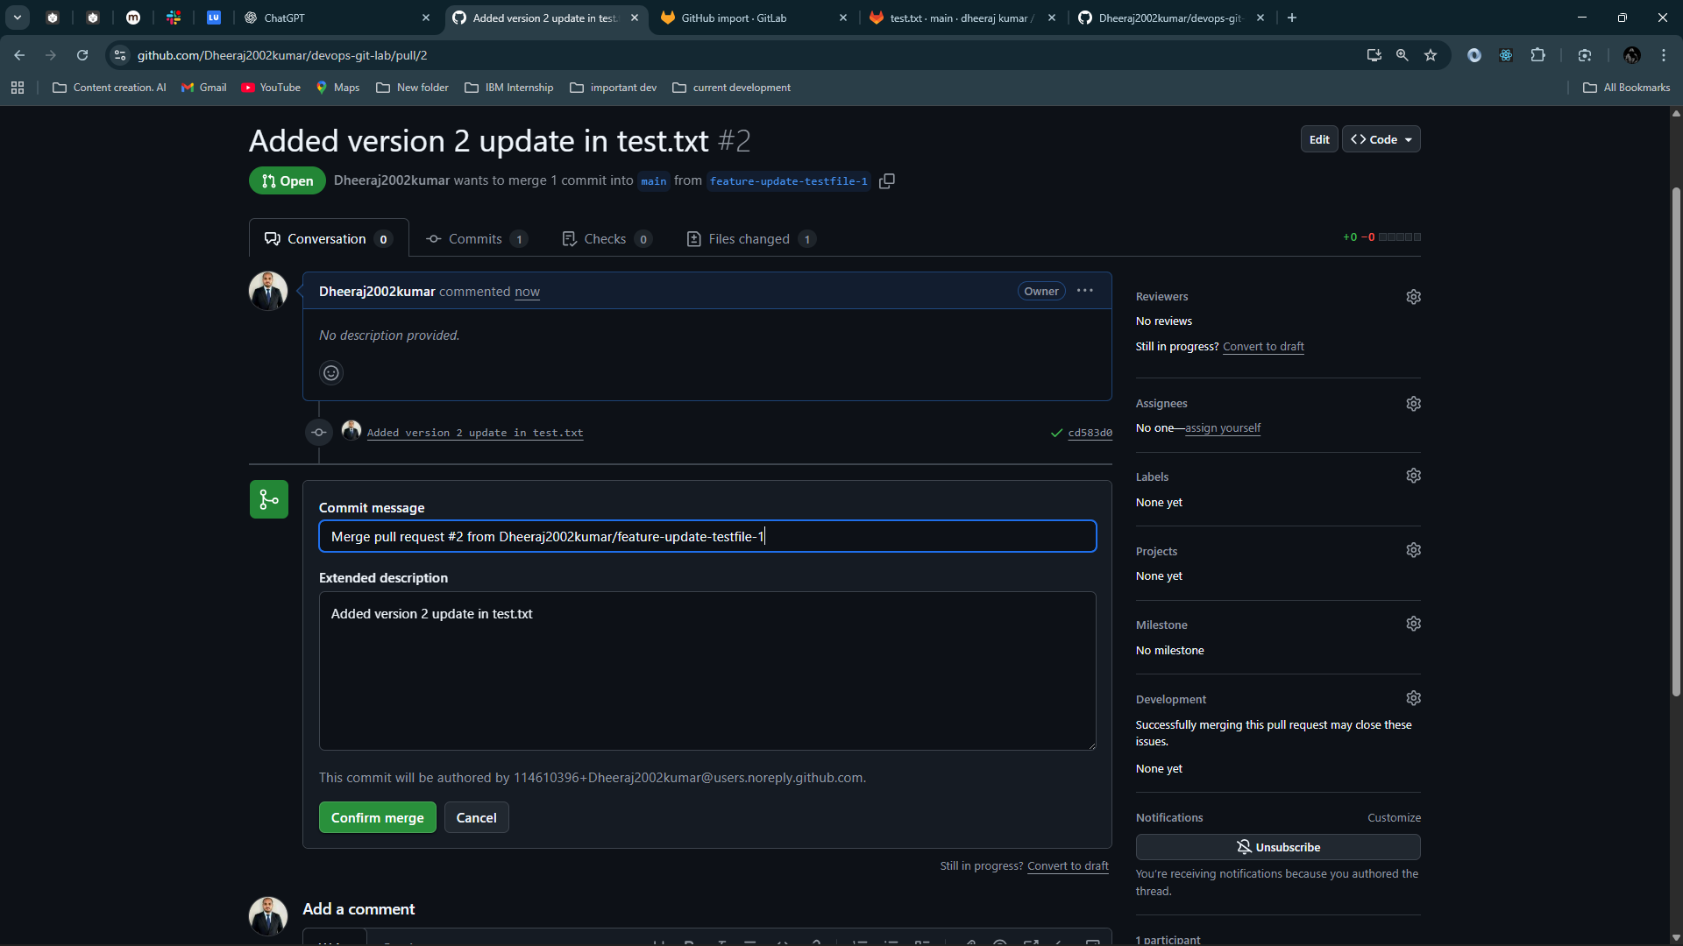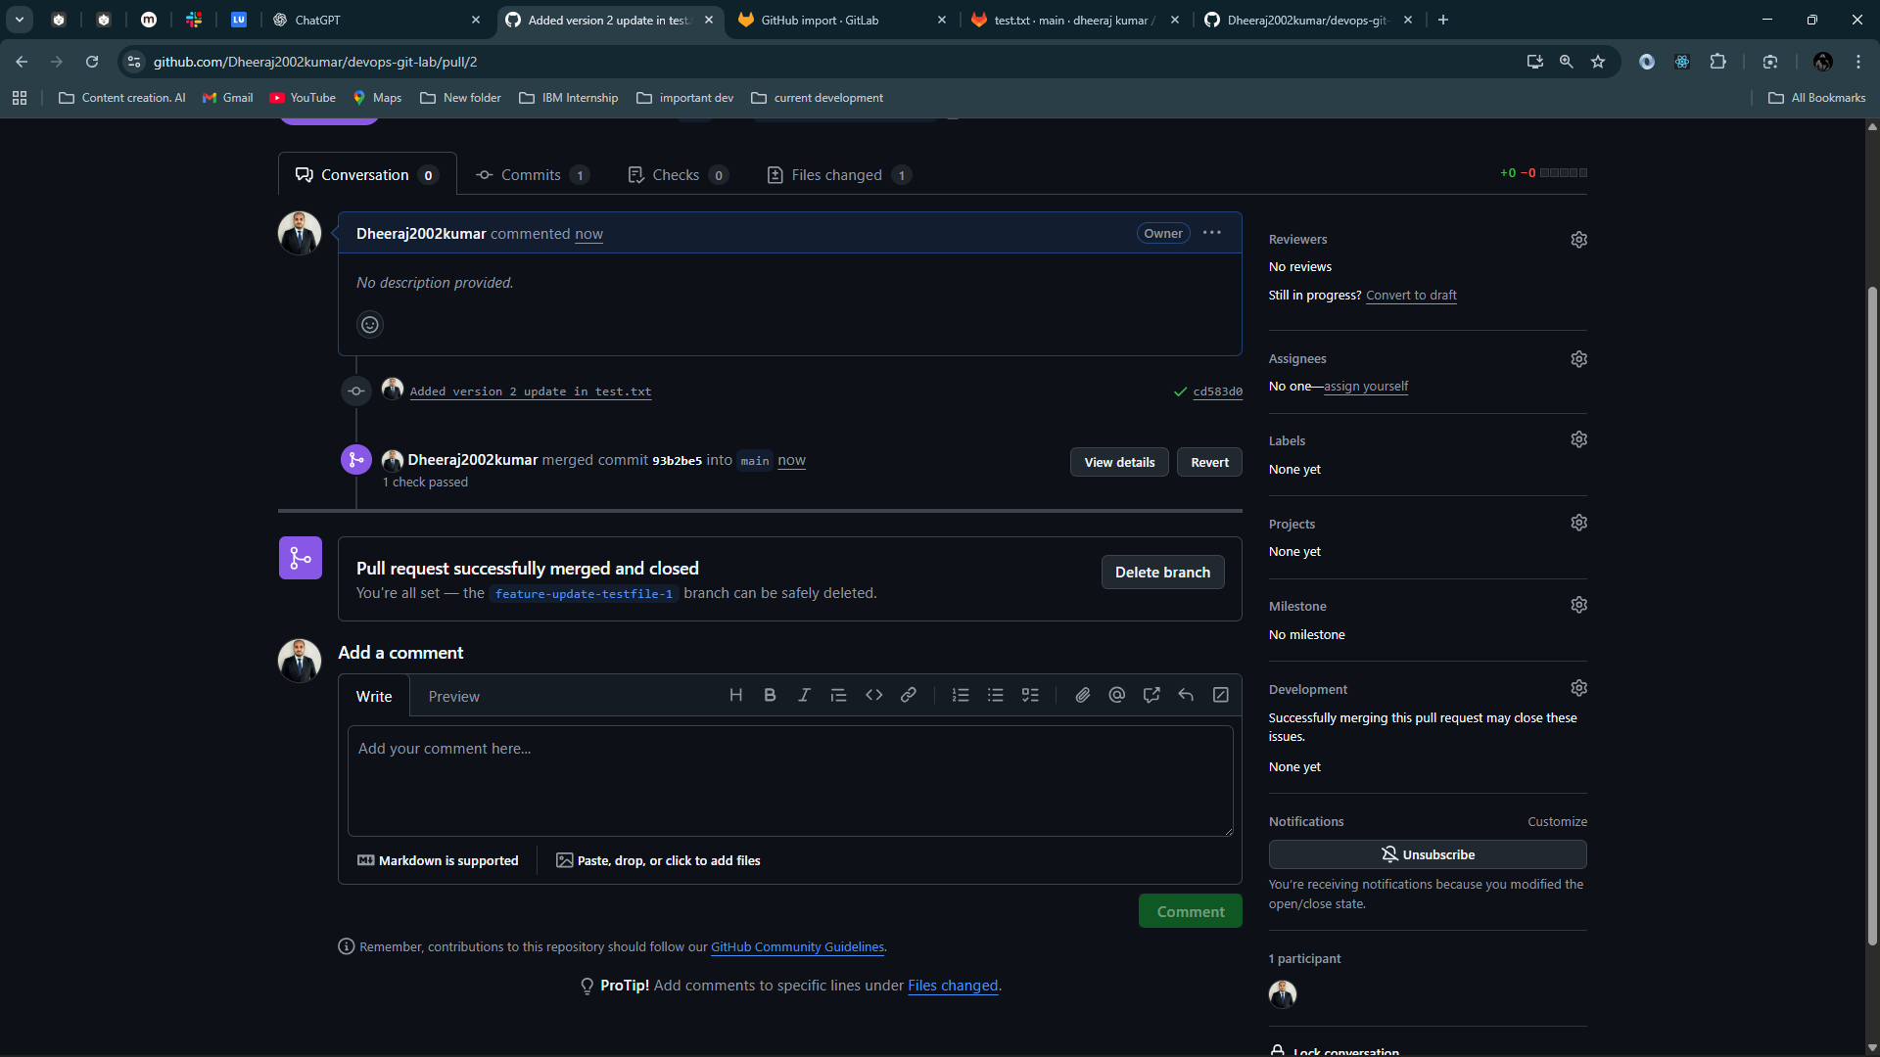

# **Mirror GitHub Repository to GitLab**

### Create a GitLab repo:

* Go to <https://gitlab.com> → New Project → **Import from GitHub**

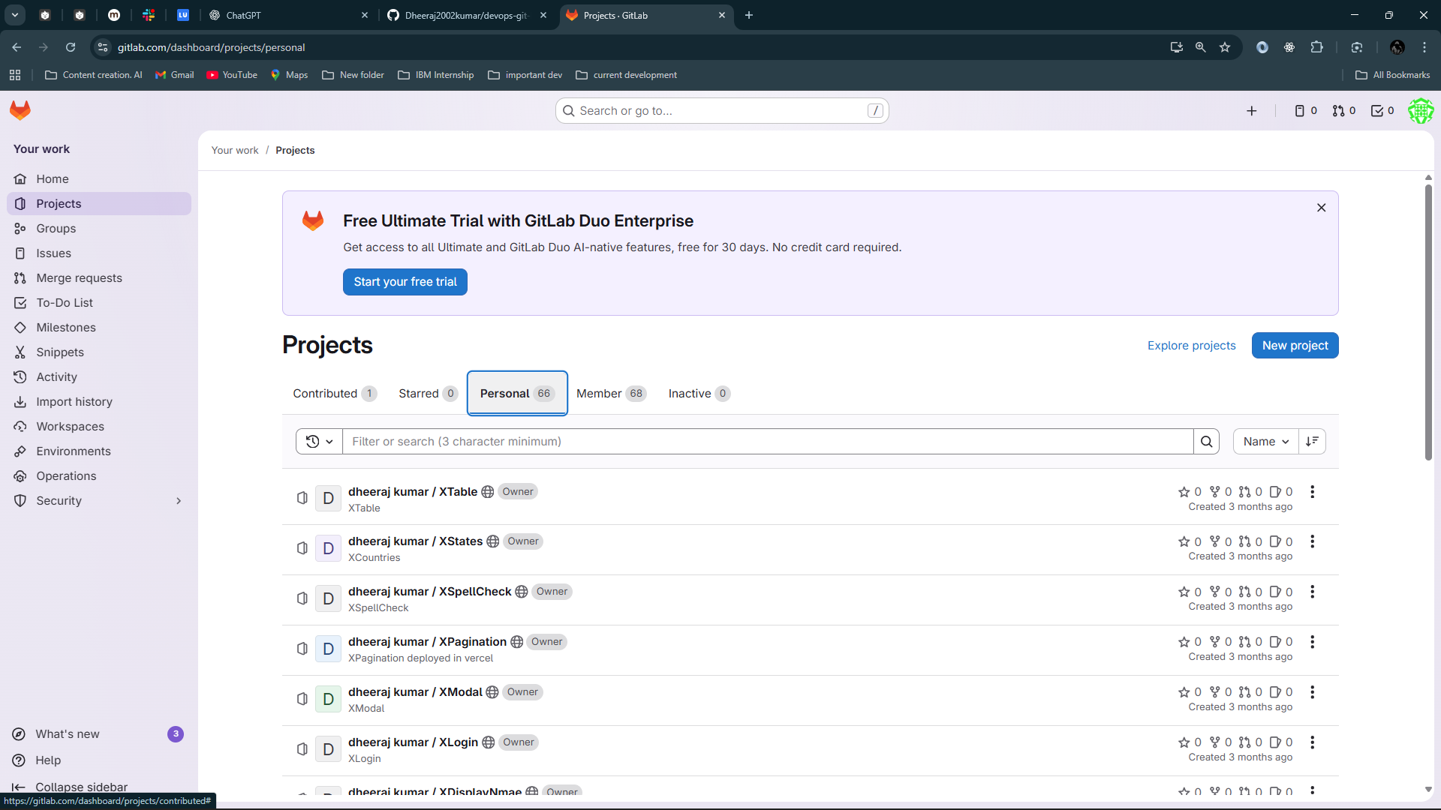

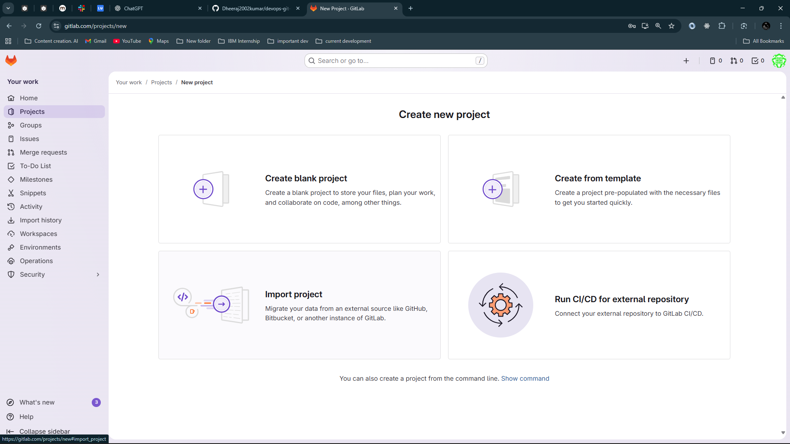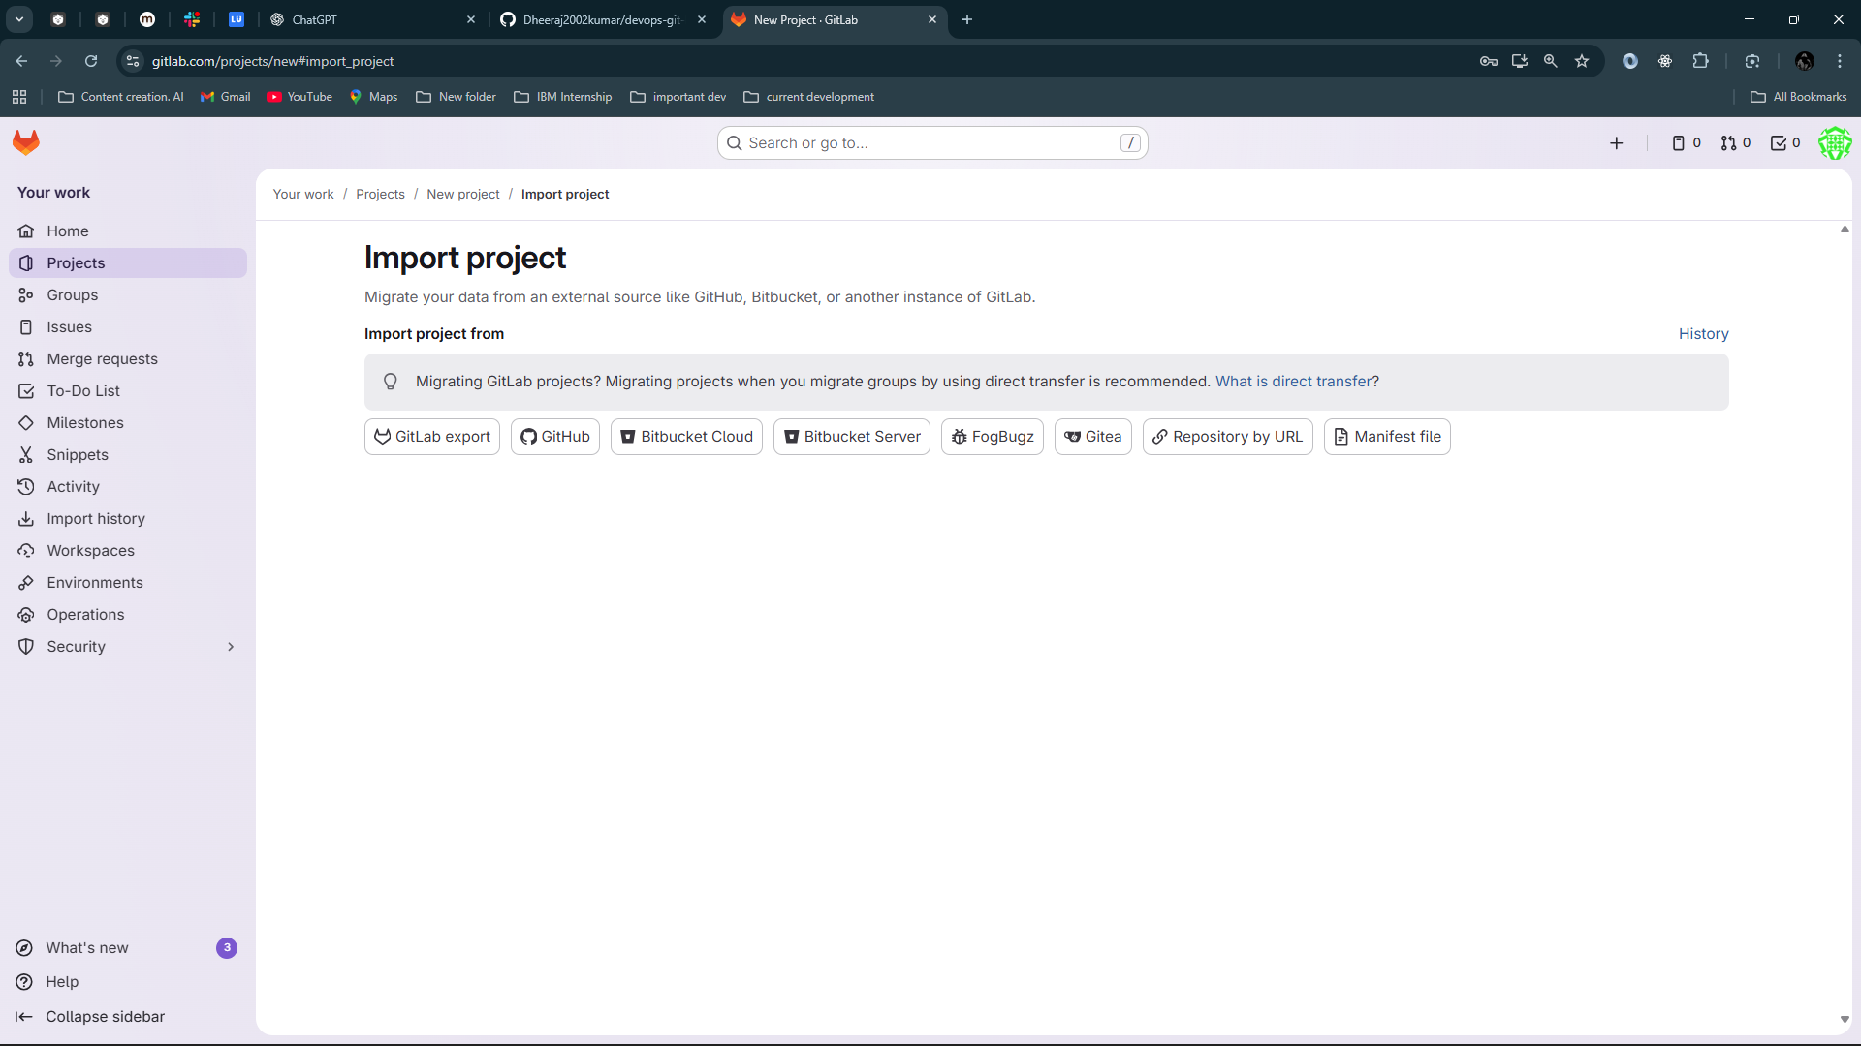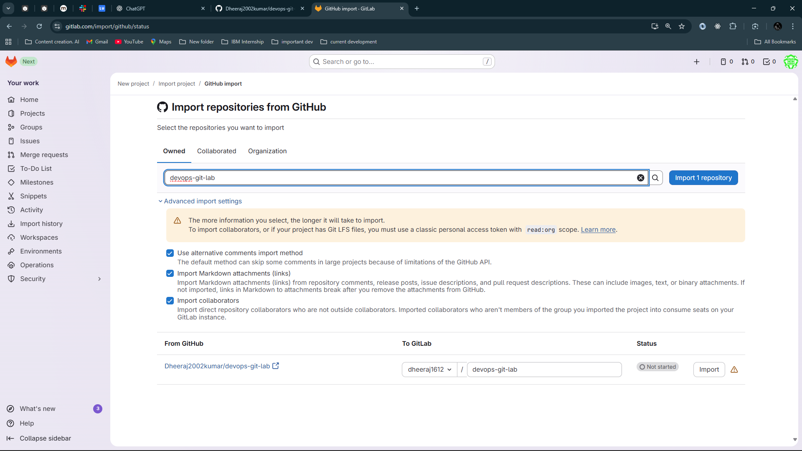

Write repository name and import it

# 

# **GitLab Collaboration Workflow**

### A teammate clones from GitLab:

git clone <https://gitlab.com/dheeraj1612/devops-git-lab.git>

cd devops-git-lab

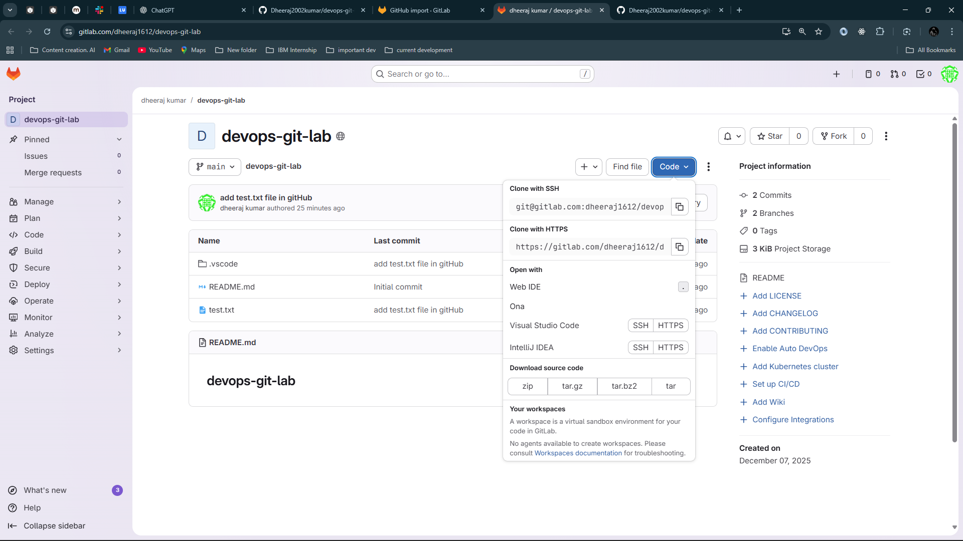

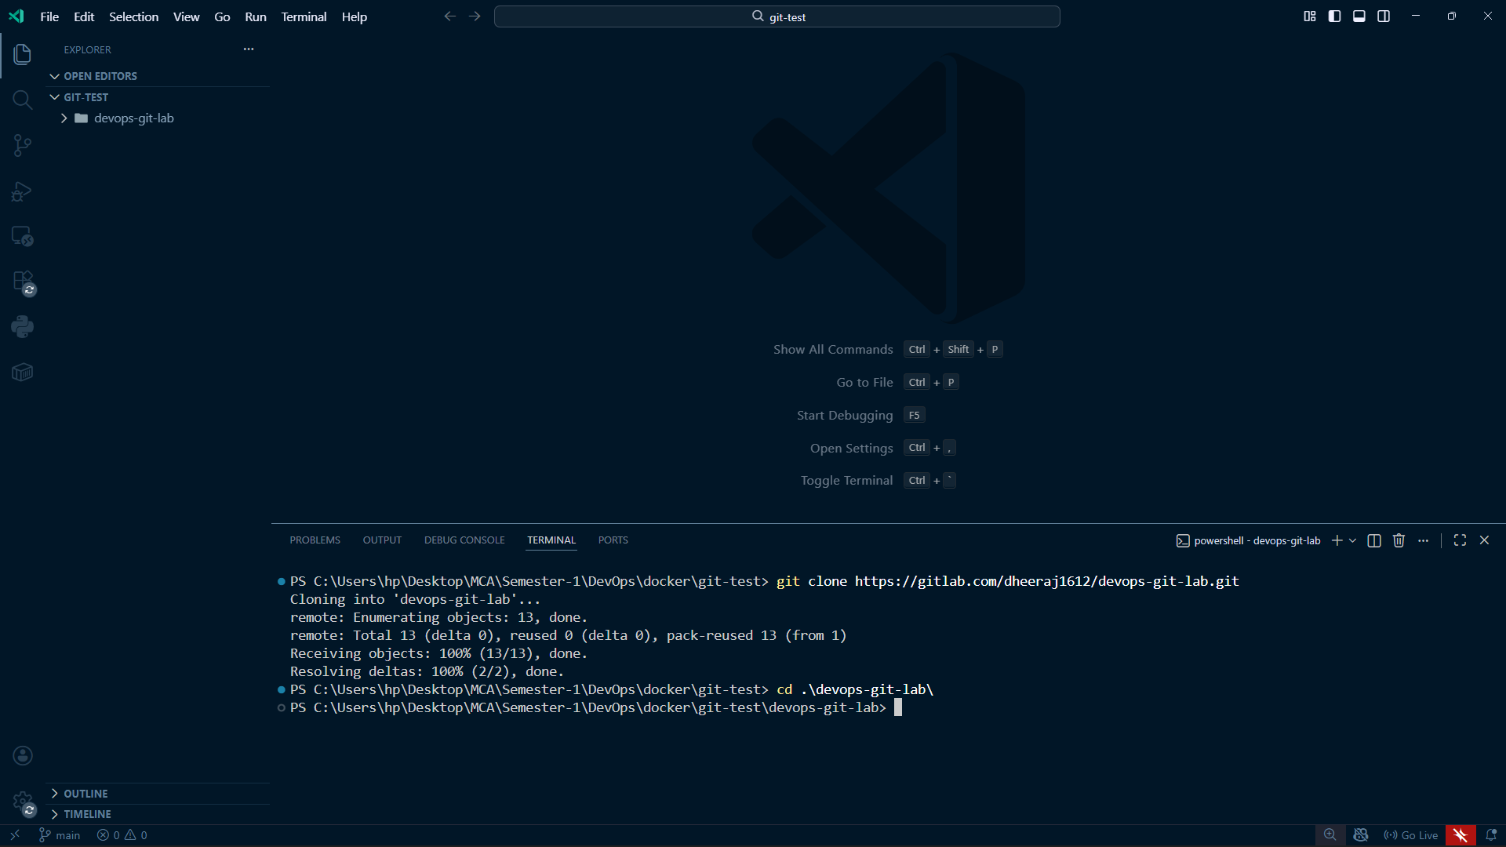

### Create a new branch:

git checkout -b feature-v3

echo "Version 3 changes" >> test.txt

git add test.txt

git commit -m "Added version 3 changes"

git push --set-upstream origin feature-v3

### On GitLab:

* Create **Merge Request**
* Run CI/CD pipeline (optional)
* Review & merge

### Sync changes back to GitHub (if mirroring enabled)

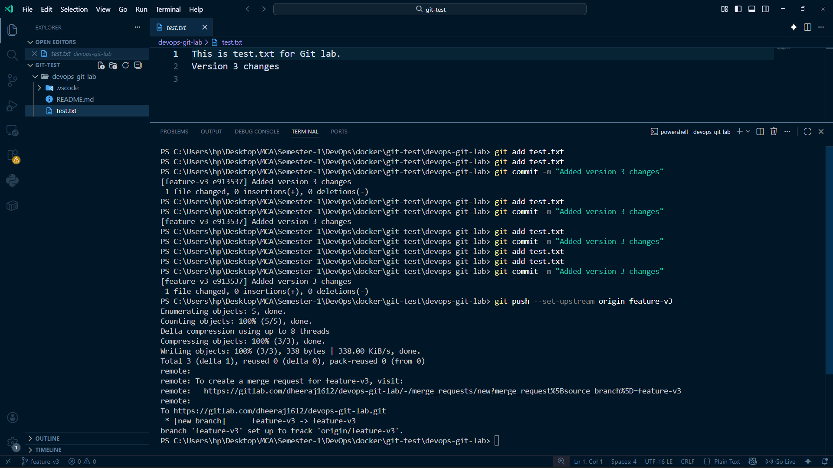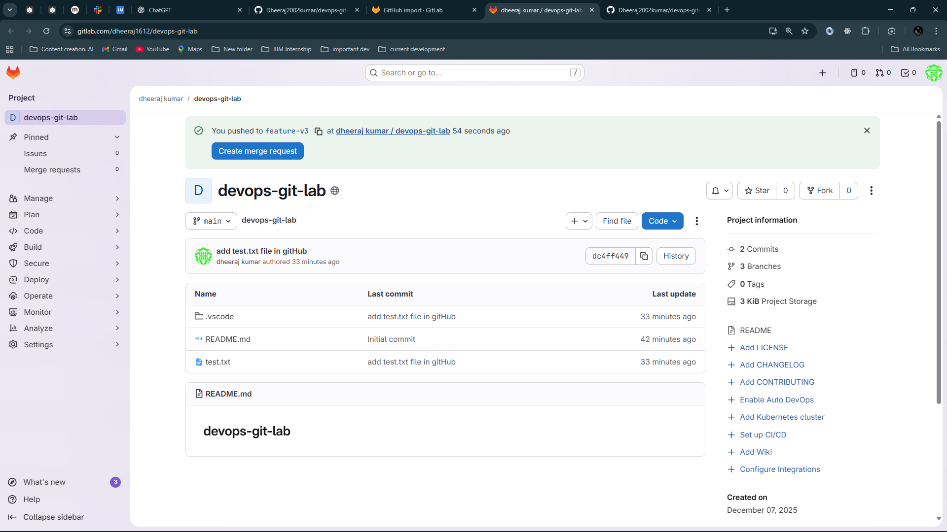

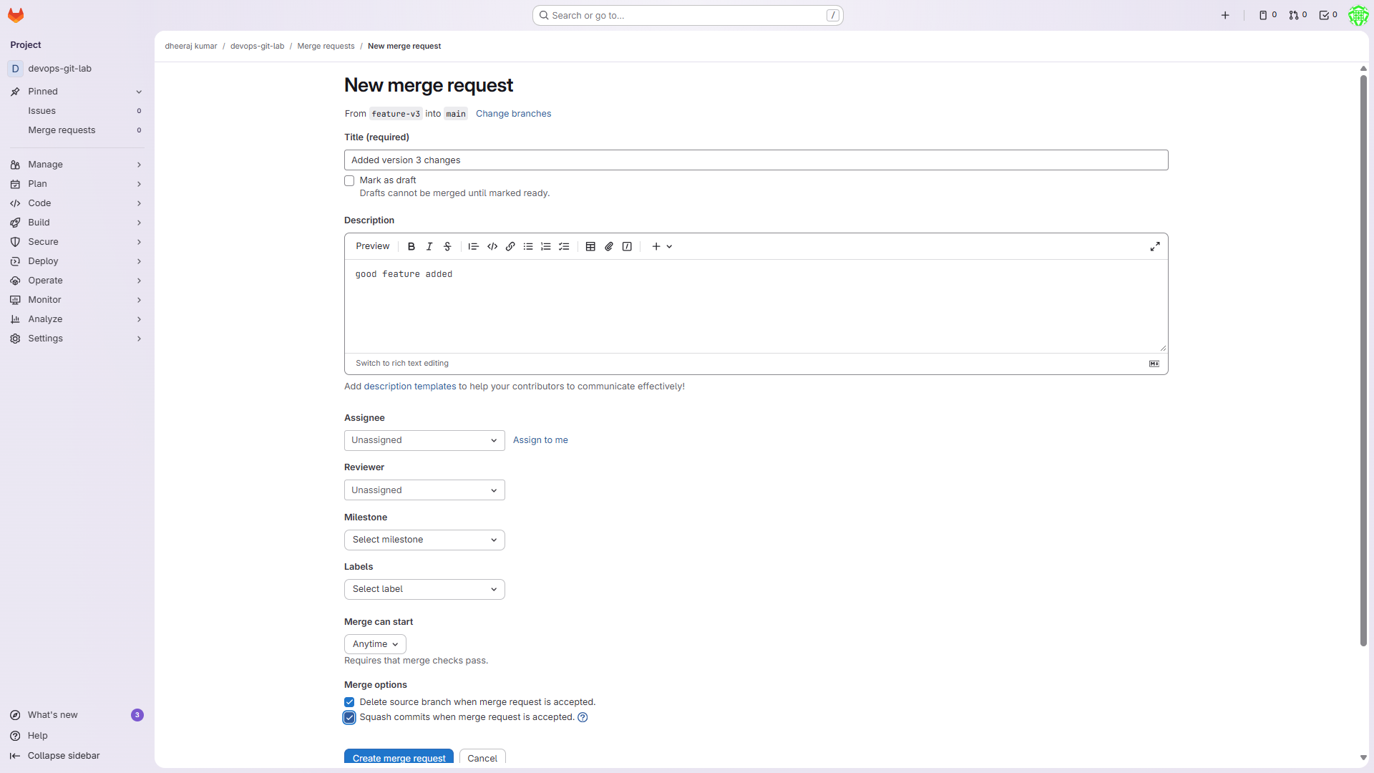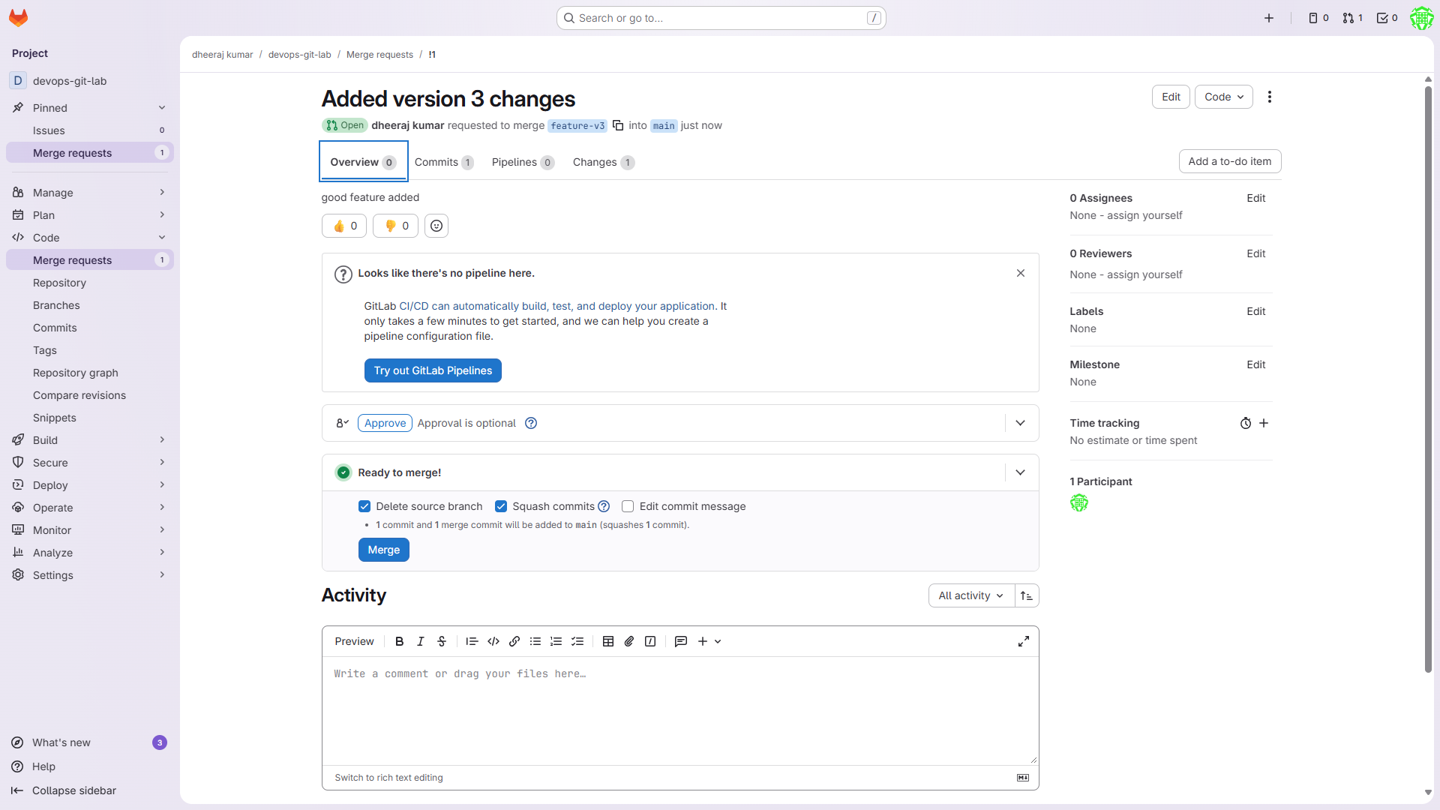

Click on merge

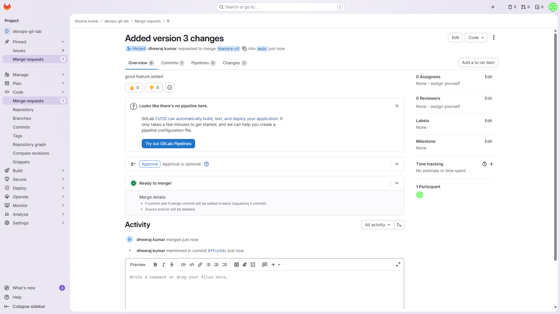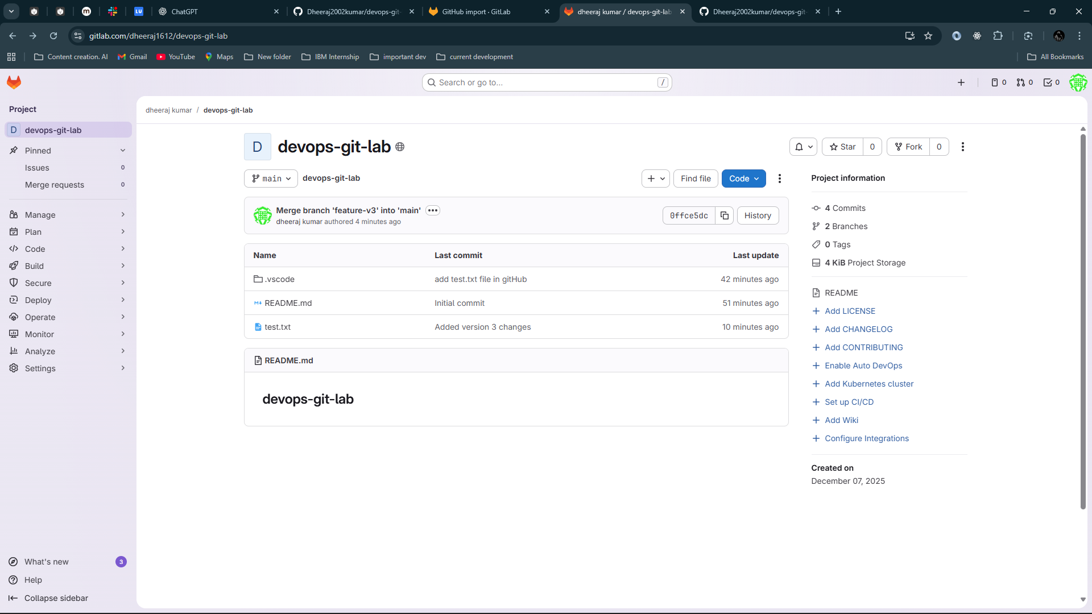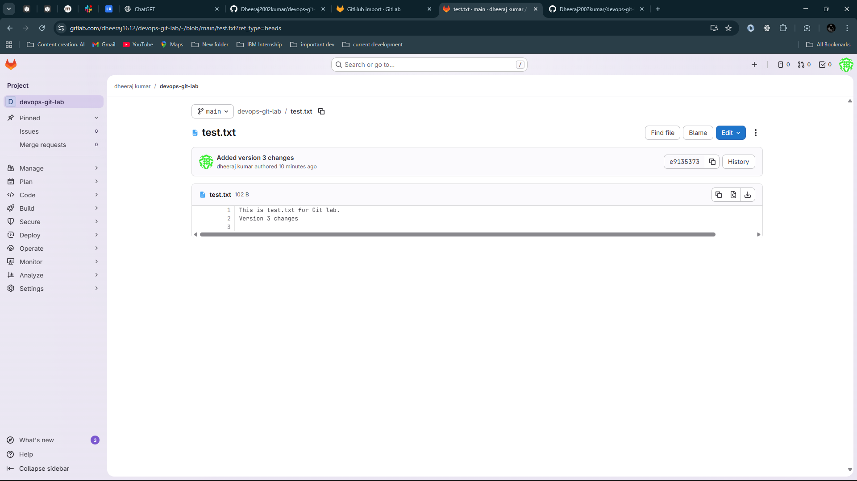

# **Checking Git History & Version Control**

Show commit log:

git log --oneline --graph --all

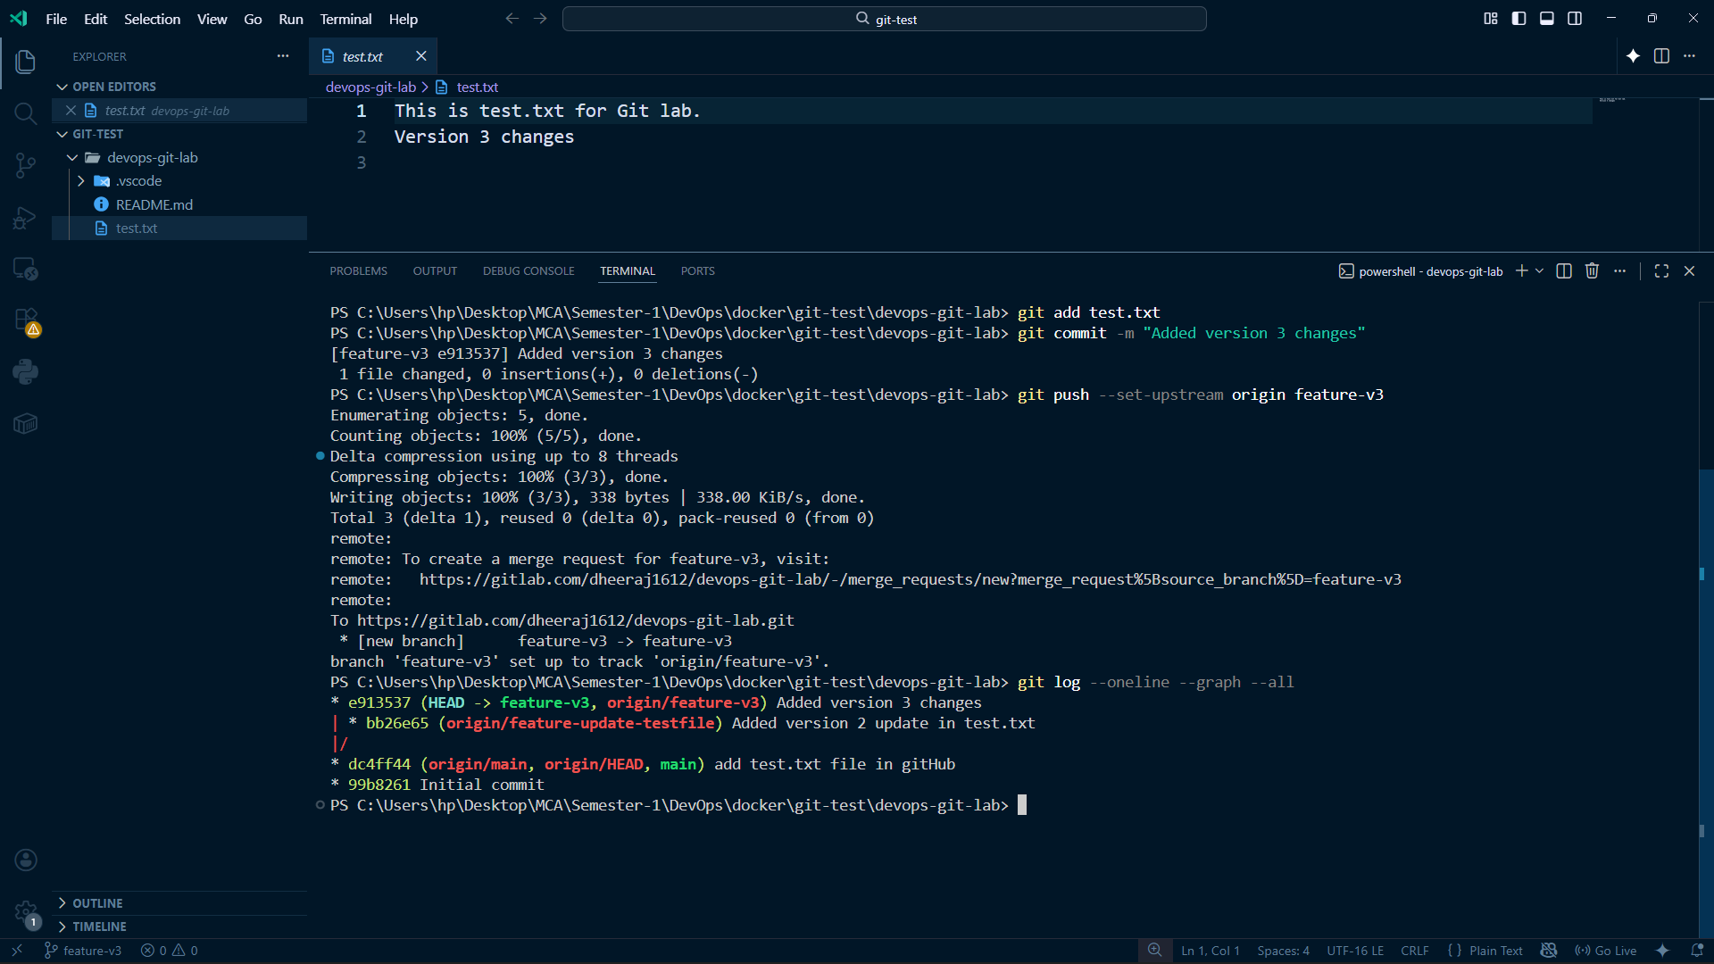

You can also merge using github